WEB TECHNOLOGY
EXPERIMENT 8 – ABHINAYA RD (241801004)

Output:
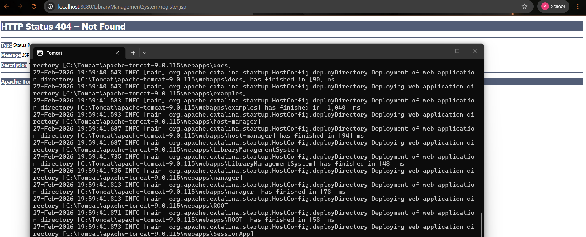
Code:
